<<AI Tools and Trends: Alumni Perspective>>

Name L.Ishitha
Roll no 2420030041
Sec-10

Organized by: Dr.V. Sahithi, KLH
Dates: September 15th,2025

Event Summary: (Brief Description in about 100-150 Words)
KLH University organized an insightful session titled “AI Tools and Trends: Alumni Perspective” on September 15. The event was coordinated by Dr. V. Sahithi and featured Mr. Bharath Kumar, a distinguished alumnus of KLH University, as the guest speaker.
The session focused on the growing influence of Artificial Intelligence in modern industries and introduced students to the latest AI tools and technologies. Mr. Bharath shared his professional experiences and provided valuable advice on how students can adapt to AI-driven trends and prepare for careers in this rapidly evolving field.

Key Highlights: (Brief Description in about 100 Words)
• Overview of cutting-edge AI tools, frameworks, and platforms used in the tech industry.
• Discussion on how AI is transforming key sectors like healthcare, finance, and education.
• Practical guidance on developing AI skills and building a career in emerging technologies.
• Real-world case studies and professional experiences shared by Mr. Bharath Kumar.
• Engaging Q&A session that allowed students to clarify doubts and discuss AI applications.

My Participation: (Brief Description in about 60-120 Words)
I participated in the “AI Tools and Trends: Alumni Perspective” session held on September 15 at KLH University. During the event, I gained valuable insights into the latest AI technologies and their practical uses in various industries. Mr. Bharath Kumar’s journey and advice motivated me to focus on skill development and continuous learning in the AI domain.
This session helped me better understand how AI is shaping the future and encouraged me to start exploring AI tools to enhance my technical knowledge and employability.

<<Event Photographs>>
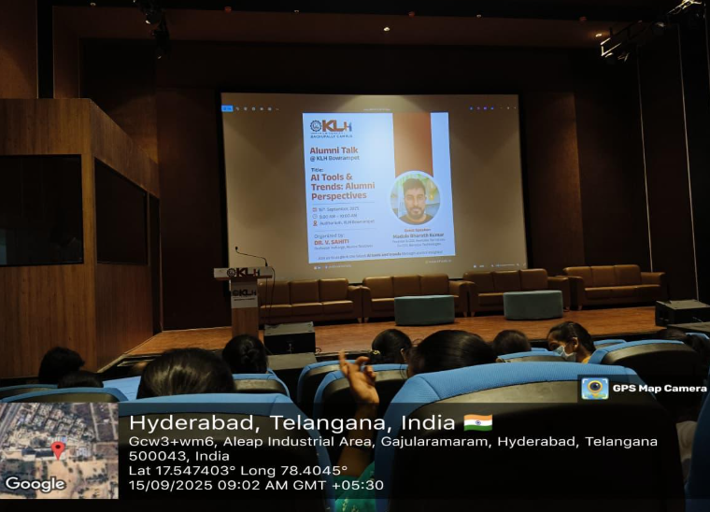

Conclusion:
In conclusion, the session on AI Tools and Trends: Alumni Perspective was highly informative and inspiring. It helped bridge the gap between academic learning and real-world applications of AI. My participation in this event strengthened my understanding of Artificial Intelligence and motivated me to stay updated with the latest advancements in technology.

Acknowledgment:
I would like to express my sincere gratitude to KLH University for organizing the insightful session “AI Tools and Trends: Alumni Perspective.” Special thanks to Dr. V. Sahithi for coordinating the event and to guest speaker Mr. Bharath Kumar for sharing his valuable knowledge and professional experiences. The event provided excellent exposure to current AI trends and encouraged students to innovate and excel in the field of technology.

